

www.UltimateKennyRogersTribute.com
FULL BAND HOSPITALITY RIDER
ACCOMMODATIONS:
5 Rooms with 2 QUEEN BEDS (to accommodate 8-9 people) located within a reasonable distance to venue. Preferably one with pool (certainly understand when not available). Typically, the band travels with 6 performers and 2 (or 3) roadcrew.
FOOD:
Please provide 8-9 healthy hot meals or a $20.00 buyout per person to be paid to road manager upon arrival at the venue.

DRESSING ROOM/GREEN ROOM:
A room to change/warmup and prep for show is greatly appreciated.

IMPORTANT ITEMS:
- 12 bottles of water. (Cold or room temperature is fine)
- 6 cans of coke (cold)
- 1 large fruit/veggie combo tray
- 1 large bottle of Pineapple Juice or 6 or so small individual cans
- 1 box of breakfast/energy bars (Kellogg’s or Nature Valley)
- 2 9-volt batteries
- 6 AA batteries

We would like to thank you for inviting us to perform at your venue. The “Hospitality Rider” helps to keep our focus on the performance before us and not having to track down essential items prior to or after the show.

If you have any questions or concerns about ANY changes to the above rider, please feel free to contact:

Alan Turner
(586) 703-8069 cell
Ron Dickinson (Road Manager/Sound Engineer)
(810) 841-7645 cell

www.UltimateKennyRogersTribute.com
FULL BAND TECHNICAL RIDER
SOUND SYSTEM
The Ultimate Kenny Rogers Tribute in concert requires a professional sound reinforcement system. This system shall be in excellent working order and free of noise or distortion. The system most adequately rated to provide sound coverage for the entire venue. When traveling with our own system we use a Midas M32 board with 6 monitor mixes. We do run a Shure In-Ear system 90% of the time but are not opposed to use individual floor wedges if necessary.

Please refer to input list on next page along with our stage plot which is below to get a feel for our needs.
Additional details can be addressed to Ron Dickinson, our Sound Engineer (810) 841-7645

Ultimate Kenny Rogers Tribute Stage Plot
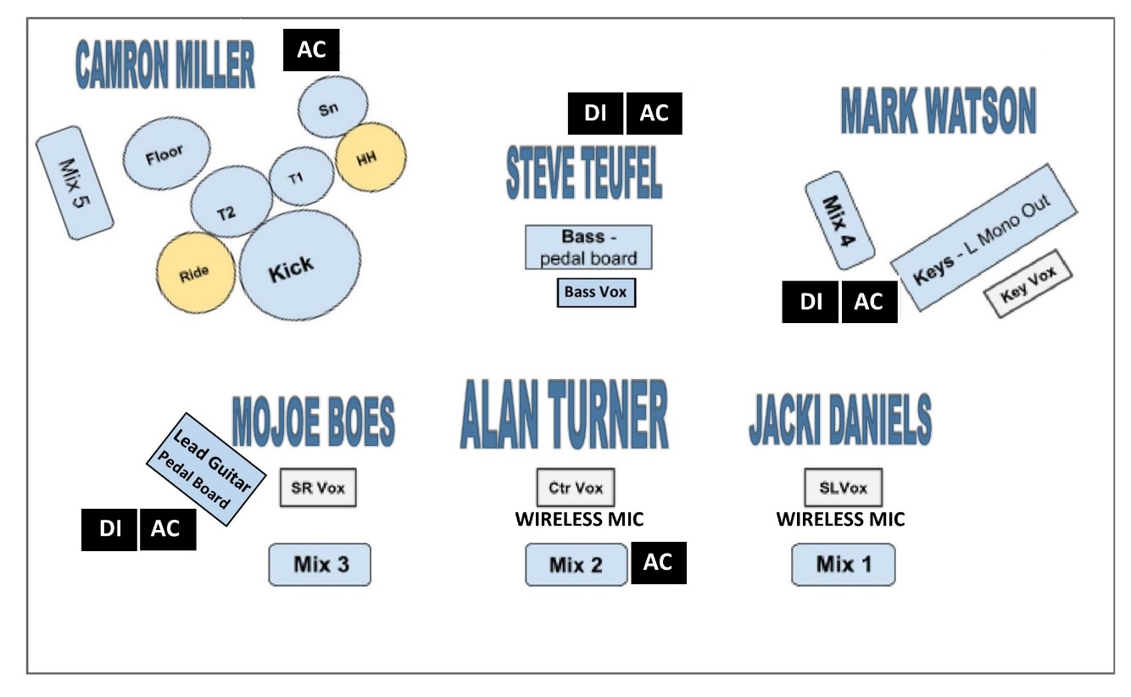

The Ultimate Kenny Rogers Tribute Show Input List
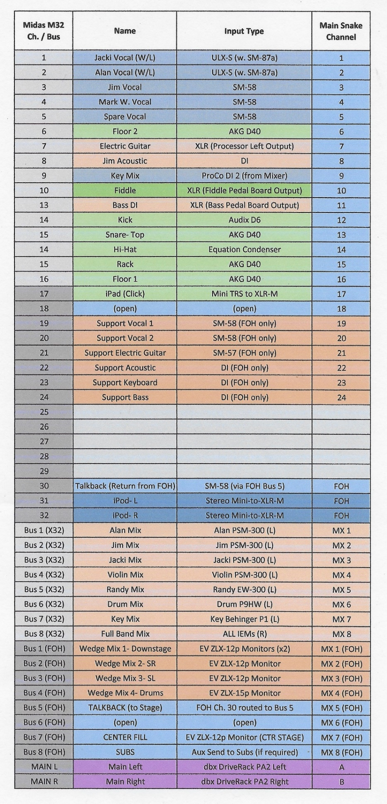

The Ultimate Kenny Rogers Tribute Show Backline
When necessary, the following is our standard backline should it need to be provided. Of course, all of this should be discussed in advance to make sure each show is properly equipped.
Vocalists: need (4) vocal mics with stands. Normally require in-ear monitor system but can work with a competent floor monitor system with individual mixes.
Guitarist:

- Guitars:
  - Martin GPC-16E acoustic with a cut away – Anything similar to this will work
  - Paul Reed Smith DGT – main guitar
  - Godin Radium-similar to this would work
- Amp
  - Fender 68’ Twin Reverb or Fender 65’ Super Reverb
    - I would carry some guitar pedals or a small pedal board to make this work
- Cables, etc:
  - 3) 18’ right angle guitar cables preferred Mogami, Pro Co, Ernie Ball
  - Floor tuner preferred Boss, Peterson
  - Guitar stand for multiple guitars
Drummer:
- Drums:
( DW, Gretsch, or Yamaha Preferred)
16” x 22” Bass drum ( 22’ Diameter a must for Logo BD head)
10” or 12” Rack Tom
14” Floor Tom or Hanging Tom
16” Floor Tom or Hanging Tom
6x14 snare (prefer wood or Black Beauty/Black Magic
- Cymbals
(Zildjain A or A Custom Prefered or Similar Sabian AA or XSR)
18” Crash
17” or 16” Crash
15” or 14” Crash
20” ride
13”or 14” Hihats
18” China
- Percussion:
1)Tambourine (Mountable) Clamping style percussion Mount
2) cowbells Low and High pitch Clamping style Percussion mount
1)Chimes w/ stand
- Hardware:
1)DW5002 Dbl Pedal Turbo(Round Sprocket)Prefered
1)DW5500 Hihat stand Prefered
1)Snare stand LOW
Drum Throne(spindle type, NOT hydraulic/Gas/Roc-n-soc Nitro)
5 Boom Cymbal stands
2 clamping Boom cymbal Arms (or Stands)

Keyboardist:
- Keyboards
  - (2) Yamaha MOXF6 Keyboards
  - (1) double tiered stand or (2) single tiered stands
  - Padded barstool
  - Heavy Duty Sheet Music Stand
  - (1) mic stand with boom

Bass Guitarist:
- Guitar:
  - (1) Fender Bass any style 5 or 4 string
  - Any bass amp with direct out –

